Имя и Фамилия Пономарёв Иван Сергеевич Дата 11.13.2024

Тестовое приложение:

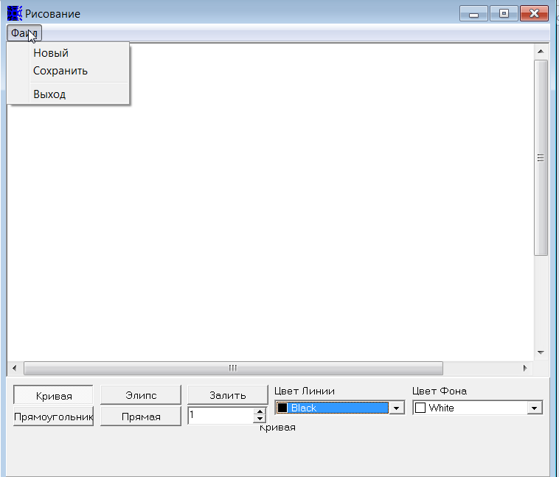

**1.Приложение для рисования разных фигур, каждая кнопка соответствует отдельной фигуре (Кривая работает как карандаш).**

**2.Что бы нарисовать фигуру, нужно выбрать фигуру нажатием на соответствующую кнопку, затем зажав левую кнопку мышки протянув по рабочей области нарисовать фигуру нужного размера.**

**3.Можно выбрать цвет линии фигуры, также можно выбрать толщину линии максимум 99 (с помощью стрелок или ввести вручную целое число).**

**4.Что бы залить фигуру, нужно выбрать цвет фона, нажать кнопку залить и затем левой кнопкой мыши нажать на области для заливки. Можно создать новый документ, а так же сохранить рисунок.**

**1.** Напишите идеи тестов, которые вы выполните для проверки работоспособности этой программы. Запишите возникшие у вас вопросы.

| Questions: | Ideas: | Expected result. |
| --- | --- | --- |
| Default settings:   1. What is the default picture button? 2. What is the default thickness? 3. What is the default line and background color? | Draw several figures with different line thickness and color. Fill the figures' backgrounds with different colors. | The application's work area displays the drawn figures with the selected colors and line thickness, as well as background colors. |
| Error and notification windows:   1. Should there be a notification asking me to save the file before closing? 2. What text should be in the window? 3. Should an error box appear when entering a line width greater than 99? 4. What should the error text be? |  |  |
| Working with a file:   1. What is the default name when creating a new file? 2. What is the default path to save a file? 3. Is it possible to choose a name for a new file? 4. Is it possible to choose a name when saving a file? 5. Is it possible to choose the path where the file is saved? 6. What is the maximum file size that can be saved? 7. What is the maximum and minimum image resolution that must be supported? |  |  |
| UI   1. What should the color range look like? 2. Should the "fill" button react somehow when pressed? Should its design change? 3. What should the picture buttons look like when you click on them? |  |  |
| 1. Drawing 2. What is the minimum line thickness? 3. At the point where you press the left mouse button on the work area, should there be the center of the drawing or its edge (for a rectangle and ellipse)? 4. If the edge, which one? |  |  |

**2.** Напишите основные тест-кейсы, которые Вы выполните для проверки работоспособности этой программы. Запишите возникшие у вас вопросы.

| ID | Priority | Req. | Module | Submodule | Descriprion | Expected result | Comments | Status |
| --- | --- | --- | --- | --- | --- | --- | --- | --- |
| 2 | smoke | 1,2 | Drawing | Ellipse | Drawing of an ellipse  Steps:  1.Open drawing.exe.  2.Click on the "ellipse" button.  3.Hold down the left mouse button while hovering over the work area and draw an ellipse. | 1.drawing.exe is displayed on the screen.  2.The button "ellipse" looks like it is pressed, namely it has become a white background without shadows.  3.The ellipse is displayed on the work area. |  |  |
| 3 | smoke | 1,2 | Drawing | Rectangle | Drawing of a rectangle  Steps:  1.Open drawing.exe.  2.Click on the "rectangle" button.  3.Hold down the left mouse button while hovering over the work area and draw an rectangle. | 1.drawing.exe is displayed on the screen.  2.The button "rectangle" looks like it is pressed, namely it has become a white background without shadows.  3.The rectangle is displayed on the work area. |  |  |
| 4 | smoke | 1,2 | Drawing | Сurved line | Drawing of a curved line  Steps:  1.Open drawing.exe.  2.Click on the "curved line" button.  3.Hold down the left mouse button while hovering over the work area and draw a curved line. | 1.drawing.exe is displayed on the screen.  2.The button "curved line" looks like it is pressed, namely it has become a white background without shadows.  3.The curved line is displayed on the work area. |  |  |
| 5 | smoke | 1,2 | Drawing | Direct line | Drawing of an direct line  Steps:  1.Open drawing.exe.  2.Click on the "Direct line" button.  3.Hold down the left mouse button while hovering over the work area and draw a direct line. | 1.drawing.exe is displayed on the screen.  2.The button "Direct line" looks like it is pressed, namely it has become a white background without shadows.  3.The direct line is displayed on the work area. |  |  |
| 1 | smoke | 1,2, 4 | Drawing | File | [TBD]Сreating a new file and saving.  Steps:  1.Open drawing.exe.  2Click on the "file" button  3.Click on the "new" button  4.Click on the "file" button  5.Click on the "save" button | 1.drawing.exe is displayed on the screen.  2.The screen displays a drop-down list "file".  3.The screen displays a new file.  4.The screen displays a drop-down list "file".  5.A notification about saving a file appeared | is it possible to choose a name for a new file? is it possible to choose a name when saving a file? is it possible to choose the path where the file is saved? |  |
| 6 | smoke | 1,2 | Drawing | Closing | Closing the application  Steps:  1.Open drawing.exe.  2.Click on the "close" button, which looks like a cross in a red rectangle on the top right. | 1.drawing.exe is displayed on the screen.  2.The application is not displayed on the screen, it has closed. | Should there be a notification asking me to save the file before closing? |  |
| 7 | extended | 1,2, 3 | Drawing | Changing color of the line | Change the color of the line and draw with that color.  Steps:  1.Open drawing.exe.  2.Click on the "line color" button.  3.Click on the desired color.  4.Hold down the left mouse button in the work area and draw a line. | 1.drawing.exe is displayed on the screen.  2.The screen displays a range of colors.  3.The "line color" button displays the selected color with the color name.  4.The working area displays a line of the selected color. | What should the color range look like? |  |
| 8 | extended | 1,2, 3 | Drawing | Change line thickness | Change line thickness and draw line of selected thickness  Steps:  1.Open drawing.exe.  2.Click on the "line thickness" field  3.Enter the line thickness (maximum 99) using the "arrow" buttons or enter from the keyboard.  4.Hold down the left mouse button in the work area and draw a line of the selected thickness. | 1.drawing.exe is displayed on the screen.  2.The cursor is displayed in the "line thickness" field.  3.The "line thickness" field displays the entered value.  4.The work area displays lines of the selected thickness. |  |  |
| 9 | extended | 1,2, 3, 4 | Drawing | Background | Fill the background of the figure with the selected color  Steps:  1.Open drawing.exe.  2.Draw a closed shape in the workspace.  3.Click on the "background color" button.  4.Click on any color.  5.Click on the "fill" button.  6.Click inside the closed shape. | 1.drawing.exe is displayed on the screen.  2.The drawn figure is displayed in the work area.  3.The range of colors is displayed.  4.The "background color" button displays the selected color with the color name.  5.The "fill" button is displayed as pressed (the button has a white background without shadows).  6.The figure's background is changed to the selected color. | Should the "upload" button react somehow when pressed? Should its design change? |  |
| 10 | extended | 1,2 | Drawing | Minimazing | Closing the application  Steps:  1.Open drawing.exe.  2.Click on the "minimize" button, which looks like a straight line in a gray-blue rectangle at the top right | 1.drawing.exe is displayed on the screen.  2.The application appears minimized. |  |  |
| 11 | extended | 1,2 | Drawing | Expanding | Closing the application  Steps:  1.Open drawing.exe.  2.Click on the "expand" button, which looks like a rectangle in a gray-blue rectangle at the top right. | 1.drawing.exe is displayed on the screen.  2.The application is displayed in full screen |  |  |
| 12 | extended | 1,2 | Drawing | Line thickness | Select line thickness greater than 99  Steps:  1.Open drawing.exe.  2.Сlick in the "line thickness" field.  3.Enter a value greater than 99 in the field using the keyboard or the "arrow" buttons. | 1.drawing.exe is displayed on the screen.  2.The cursor is displayed in the "line thickness" field.  3. A window appears with the error text (maximum line thickness = 99). |  |  |
| 13 | extended | 1,2 | Drawing | Line thickness | Select line thickness less than 0  Steps:  1.Open drawing.exe.  2.Сlick in the "line thickness" field.  3.Enter a value less than 0 in the field using the keyboard or the "arrow" buttons. | 1.drawing.exe is displayed on the screen.  2.The cursor is displayed in the "line thickness" field.  3. A window appears with the error text (thickness cannot be negative). |  |  |
| 14 | extended | 1,2 | Drawing | Line thickness | Select line thickness = 0  Steps:  1.Open drawing.exe.  2.Сlick in the "line thickness" field.  3.Enter a value 0 in the field using the keyboard or the "arrow" buttons. | 1.drawing.exe is displayed on the screen.  2.The cursor is displayed in the "line thickness" field.  3. A window appears with the error text (thickness cannot be equal to 0.). |  |  |

| **3.** Напишите баг-репорты по замеченным «нюансам работы» приложения. Запишите возникшие у вас вопросы. **Пожалуйста, начните с наиболее серьёзных ошибок!**   | **Bug ID** | **1** | | --- | --- | | **Severity** | **Major** | | **Summary** | **When selecting line thickness using the arrow buttons, the application allows you to enter a value greater than 99.** | | **Decription** | **Open the application. Using the "arrow" buttons, enter a value higher than 99. The application does not give errors and allows you to draw lines with this thickness value.** | | **Steps to reproduce** | **1.Open the application.**  **2.Click in the "line thickness" field.**  **3.Using the arrow buttons, enter a value greater than 99.** | | **Actual result** | **A value above 99 is entered without errors and allows you to draw lines of this thickness.** | | **Expected result** | **An error window appears about exceeding the maximum line thickness value (more than 99).** | | **Attachments** |  | | **Bug ID** | **2** | | **Severity** | **Major** | | **Summary** | **When selecting line thickness using the arrow buttons or keybord, the application allows you to enter a value less than 0.** | | **Decription** | **Open the application. Using the "arrow" buttons щк keyboard, enter a value less than 0. The application does not give errors and allows you to draw lines with this thickness value.** | | **Steps to reproduce** | **1.Open the application.**  **2.Click in the "line thickness" field.**  **3.Using the arrow buttons or keybord, enter a value less than 0.** | | **Actual result** | **The value is displayed in the "line thickness" field. The application allows you to draw with this line thickness, but the lines are displayed with a thickness of 1.** | | **Expected result** | **An error window appears about exceeding the minimum line thickness value (less than 1).** | | **Attachments** |  | | **Bug ID** | **3** | | **Severity** | **Major** | | **Summary** | **When trying to fill the background with color, when the line thickness value is not specified, an error appears about an invalid value.** | | **Decription** | **If the "line thickness" field is empty, it does not allow the background to be filled with color; an error about an invalid value appears.** | | **Steps to reproduce** | **1.Open the application.**  **2.Click in the "line thickness" field.**  **3.Remove the value from the field.**  **4.Click on the "fill" button**  **5.Click on the application workspace.** | | **Actual result** | **An error appears with the text about an invalid value.** | | **Expected result** | **The background changes to the color we choose.** | | **Attachments** |  | | **Bug ID** | **4** | | **Severity** | **Major** | | **Summary** | **When selecting line thickness using the arrow buttons or keybord, the application allows you to enter a value = 0.** | | **Decription** | **Open the application. Using the "arrow" buttons щк keyboard, enter a value = 0. The application does not give errors and allows you to draw lines with this thickness = 1.** | | **Steps to reproduce** | **1.1.Open the application.**  **2.Click in the "line thickness" field.**  **3.Using the arrow buttons or keyboard, enter a value = 0.** | | **Actual result** | **Lines are displayed with a thickness of 1** | | **Expected result** | **An error window appears with text stating that the line thickness cannot be equal to 0.** | | **Attachments** |  | | **Bug ID** | **5** | | **Severity** | **Minor** | | **Summary** | **The button has a name “Фаил” instead “Файл”.** | | **Decription** | **In the open application the button has an incorrect name, namely “Фаил” instead of “Файл”.** | | **Steps to reproduce** | **1.Open the application.**  **2.Look at the "file" button** | | **Actual result** | **The button has a name “Фаил”.** | | **Expected result** | **The button has a name “Файл”.** | | **Attachments** |  | | **Bug ID** | **6** | | **Severity** | **Minor** | | **Summary** | **In the application, under the "line color" button, there is an extra inscription "Curve"** | | **Decription** | **In the application, under the "line color" button, there is an extra inscription "Curve", which does not mean anything and does not change when you select, for example, a rectangle or an ellipse.** | | **Steps to reproduce** | **1.Open the application.**  **2.Look at the space below the "line color" button** | | **Actual result** | **The inscription "curve" is displayed** | | **Expected result** | **The space is empty** | | **Attachments** |  | | **Bug ID** | **7** | | **Severity** | **Minor** | | **Summary** | **The button has a name “Элипс” instead “Эллипс”.** | | **Decription** | **In the open application the button has an incorrect name, namely “Элипс” instead of “Эллипс”.** | | **Steps to reproduce** | **1.Open the application.**  **2.Look at the "file" button** | | **Actual result** | **The button has a name “Фаил”.** | | **Expected result** | **The button has a name “Файл”.** | | **Attachments** |  | | |
| --- | --- | --- | --- | --- | --- | --- | --- | --- | --- | --- | --- | --- | --- | --- | --- | --- | --- | --- | --- | --- | --- | --- | --- | --- | --- | --- | --- | --- | --- | --- | --- | --- | --- | --- | --- | --- | --- | --- | --- | --- | --- | --- | --- | --- | --- | --- | --- | --- | --- | --- | --- | --- | --- | --- | --- | --- | --- | --- | --- | --- | --- | --- | --- | --- | --- | --- | --- | --- | --- | --- | --- | --- | --- | --- | --- | --- | --- | --- | --- | --- | --- | --- | --- | --- | --- | --- | --- | --- | --- | --- | --- | --- | --- | --- | --- | --- | --- | --- | --- | --- | --- | --- | --- | --- | --- | --- | --- | --- | --- | --- | --- | --- | --- |

4. Написать саммари к TRR (задание выполняется опционально)

Environment: Windows 10 pro Build 10.

7 bugs found.

Of the bugs found, 4 were major and 3 were minor.

The quality is not perfect, but no critical bugs were found in the application, which is good at this stage of development.

**Recommendations:**

It is advisable to pay attention to regression testing before introducing new functionality.